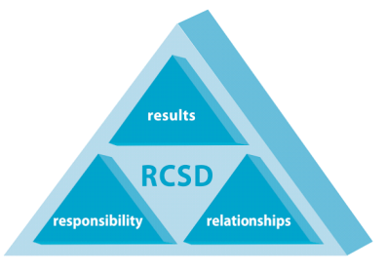

Gina Sudaria
Interim Superintendent
Ravenswood City School District
BUSINESS SERVICES
2120 Euclid Avenue, East Palo Alto, California 94303
(650) 329-2800 Fax (650) 323-1072

Board Members:
Tamara Sobomehin, President
Ana Maria Pulido, Member
Sharifa Wilson, Member
Marielena Gaona Mendoza, Clerk
Stephanie Fitch, Vice President

“OUR CHILDREN – OUR FUTURE”

Memorandum of Understanding
BETWEEN

Ravenswood City School District
AND
All Students Matter

This Memorandum of Understanding (MOU) describes and confirms an agreement between the Ravenswood City School District (DISTRICT) and All Students Matter (ASM). The purpose of this agreement is to formalize and clarify any expectations of and the relationship between the parties involved, thereby ensuring an effective working relationship for the implementation of All Students Matter program.

I. DESCRIPTION OF SERVICES and PURPOSE OF COLLABORATION

Our Strong Partnership - For the last 11 years All Students Matter has had a strong partnership with RCSD. We exclusively support the District and are guided by the RCSD staff, principals and teachers. Our mission is to provide trained volunteers to support RCSD elementary school classroom teachers. We have surveyed the teachers we support for the last three years and found our effort has significantly improved the academic performance of the students we work with as well as the students’ self-esteem. Our over 200 dedicated ASM volunteers go into the Ravenswood schools every week, all school year, with a strong commitment to the staff, teachers and students of RCSD.

We are requested – ASM never enters a school or classroom that doesn’t want our help. We have only had two classrooms in 11 years that did not want volunteer support.

We are trained – ASM volunteer training is designed and reviewed by District staff. It is critical we mirror the approaches used in the classroom which include improving the literacy, common core math and social/emotional skills of the students. Training is provided to new volunteers in September. Additional training is provided through ASM Quarterly Newsletters, ASM Lecture Series, and individual volunteer shadowing with our ASM Program Director.

We serve all the RCSD elementary schools – We currently support all T/K-5th grade classrooms at Willow Oaks, Brentwood Academy, Belle Haven, and Costano schools. We support Los Robles in 3rd - 5th grades with bilingual volunteers. We provide teachers with an average of three trained volunteers that come every week, for the full school year.

We are reliable – Our volunteers not only commit to support a District classroom every week, all school year, but they stay on average with ASM for three years. This dedication and reliable support is invaluable for the teachers we serve.

We are organized – Every school we support has two ASM Site Directors that not only volunteer in the classroom but interface with their school’s volunteers, teachers and principals. ASM Site Directors meet regularly at grade level teacher meetings to discuss the volunteer effort and needs of the teachers. They also are responsible for scheduling all volunteers and inputting the data in our database by September. The ASM Leadership Team, a management team of 15 volunteers, including the Site Directors, meet quarterly to discuss our performance and challenges facing the organization. In addition, the ASM Board guides ASM and meets semiannually to discuss strategic plans, financial performance and key factors for success.

New 2019-2020 ASM Support – Lead by Lara Burenin, RCSD Director of Curriculum & Instruction
TOSA/Literacy Coach Support -This year ASM will double the number of trained volunteers to support the TOSAs/Literacy Coaches at Willow Oaks, Brentwood Academy, Belle Haven and Costano schools. The TOSAs/Literacy Coaches will provide training and lesson plans for the volunteers to implement. Our volunteers will come at the same day and time, every week, all school year, to support students the TOSAs/Literacy Coaches select.
Book Club – ASM will expand our third trimester, weekly Book Club in the fifth grades to include all 5 RCSD elementary schools. The book club groups will focus on comprehension, higher order thinking, and balanced literacy.

It has been our honor to serve this District’s teachers over the years and inspire their students to achieve their potential. We hope to serve the District many years to come.
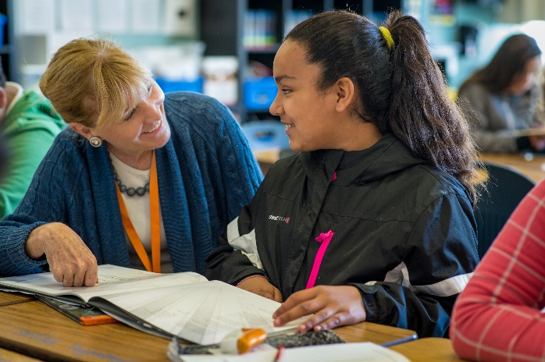

II. TERMS OF UNDERSTANDING

This agreement is effective on _August 2019__ and will remain in effect until _June 2020__, unless terminated pursuant to Section IX. The MOU shall be reviewed quarterly to ensure that it is fulfilling its purpose and to make any necessary revisions.

Amendments to this MOU must be provided to all signing persons and will become effective upon the signed approval of all parties.

III. SCHOOL and DISTRICT OBLIGATIONS

- The DISTRICT will ensure that an appropriate administrator will be designated for assistance in implementing the All Students Matter program. The administrator will perform, but is not limited to, the following functions:

Ensure All Students Matter program integrate with the goals of the district.
Principals provide ASM with teachers emails and classrooms.
Teachers provide students and reading levels for volunteers when appropriate.

- The DISTRICT agrees to appoint District staff, as necessary, to act as the primary point of contact between All Students Matter and RCSD for the development of a strategic plan for serving Ravenswood students.

- The DISTRICT agrees that District staff will help facilitate the process to gain access to program needs such as appropriate space, student information, etc.

- The DISTRICT agrees that Ravenswood City School District will act as primary reporting agency when a staff person informs school staff of reasonable suspicion of child abuse, child neglect, harm to self or harm to others of a student residing in the district.

- The DISTRICT will provide professional development to assist All Students Matter in aligning literacy and math volunteer training to the DISTRICT Common Core curriculum. (INCLUDE ONLY IF APPLICABLE)

- The DISTRICT will provide student report card and student progress information to All Students Matter for instructional placement. (INCLUDE ONLY IF APPLICABLE)

RCSD agree to the reporting process outlined in Appendix A.

IV. All Students Matter

- All Students Matter agrees to provide stated service as in Section I to the schools identified in section III.A.2. Activities outside those specified in the stated services (section I) will be determined jointly by representatives from DISTRICT and All Students Matter (e.g. field trips, etc.).

- All Students Matter agrees to collaborate with the Director of Student Services and/or District Summer Program Coordinator and other RCSD staff in providing timely attendance reports, programming updates, student reports, accountability reports, and other unspecified reporting.

- All Students Matter agrees to work with RCSD Child Nutrition Services for any food service needs.

- All Students Matter agrees that services provided by All Students Matter pursuant to this MOU may be supervised and evaluated by staff from the Ravenswood City School District as a supplement to All Students Matter primary oversight.

- All Students Matter staff will ensure that there is 20:1 student to supervisory staff ratio at all times.

- All Students Matter will ensure that all staff in a supervisory position within the 20:1 ratio will fulfill the requirements for an instructional aid status (NCLB compliant) as listed below:
- have an AA or BA degree or
- have 48 semester or 72 quarter college units or
- Have a passing status on the Instructional Aid Exam administered by RCSD.

- All Students Matter agrees to provide orientations/presentations to district representatives, program staff, school staff and parents for informative purposes.

- All Students Matter agrees to provide the DISTRICT with a schedule and calendar of daily activities and upcoming events and to coordinate with the Assistant Superintendent of Curriculum & Instruction and/or other District Staff in the planning and coordination of these events.

- All Students Matter agrees that when its interns and volunteers are utilized, staff from All Students Matter will be responsible for their training, supervision, TB clearance, fingerprinting, federal criminal background check, and of ensuring that such person fulfills all district requirements for instructional aid status if this person is in a supervisory position within the 20:1 student to staff ratio.

- All Students Matter agrees to ensure that all of their staff who will be on school property or work with students has proof of a negative skin test or chest x-ray for Tuberculosis. All Students Matter will provide RCSD with written verification that program staff has been cleared.

- All Students Matter agrees to ensure that all program staff that will be on school property has proof of FBI and Department of Justice Child Abuse Index fingerprint clearance. All Students Matter will provide RCSD with written verification that program staff has been cleared.

- All Students Matter agrees that in every case where a program staff person has reasonable suspicion of child abuse, child neglect, harm to self or harm to others of a student residing in the district, the staff person will comply with the reporting process outlined in Appendix A.

- All Students Matter has in force, and during the term of this Agreement shall maintain in force, a Comprehensive General Liability Insurance policy with limits not less than $1,000,000.00 (one million dollars) each occurrence combined Single Limit for Bodily Injury and Property Damage. The policy shall name as additional insured the Ravenswood City School District, its Board, officers and employees. The policy shall require the insurer to provide to the District a thirty- (30) day notice of any cancellation or reduction of such insurance.

V. CONFLICT RESOLUTION

The Parties agree that differences of opinion regarding personnel or service practices or Parties will be discussed. If resolution is not obtained then, decisions will be made after discussion between the Director of Student Services, Assistant Superintendent of Curriculum & Instruction, and All Students Matter management representatives.

VI. NON-DISCRIMINATION

All Students Matter and the DISTRICT shall not discriminate against any person rendering or receiving services pursuant to this Memorandum, on the basis of race, color, age, marital status, national origin, sex, creed, sexual orientation, or physical or mental disability, including HIV disease, as provided by State and Federal Law.

VII. HOLD HARMLESS

Each party is an independent contractor responsible for its acts and the acts of its officers, agents, and employees. Each party agrees to indemnify, defend, and hold harmless the other party, its officers, agents, and employees from any and all loss, injury, liability, damages, claims, demands, suits, or judgments arising from the acts or omissions of its officers, agents, and employees in connection with the performance of this agreement.

VIII. CONFIDENTIALITY

The parties shall maintain the confidentiality of all records generated during the period of this agreement pursuant to applicable Federal and State laws.

IX. TERMINATION

This Agreement may be terminated by either party by giving a minimum of thirty (30) days advance written notice to all parties.

X. NOTICES

All notices of the parties shall be in writing and shall be addressed as set forth below:

All Students Matter  Angie Holman  Executive Director  20 Willow Rd. #42 Menlo Park, CA 94025  (650) 714-2095  angie@allstudentsmatter.org | TO SCHOOL DISTRICT:  Gina Sudaria, Interim Superintendent  Ravenswood City School District  2120 Euclid Avenue  East Palo Alto, CA 94303

Copy to: | Lara Burenin  Director of C&I  Ravenswood City School District  2110 Euclid Avenue  East Palo Alto, CA 94303

Copy to: | Business Services  Ravenswood City School District  2110 Euclid Avenue  East Palo Alto, CA 94303
SIGNATURE PAGE

XI. AUTHORIZATION

The signing of this MOU is not a formal undertaking. It implies that the signatories will strive to reach, to the best of their ability, the objectives stated in the MOU.

On behalf of the organization I represent, I wish to sign this MOU and contribute to its further development.

RAVENSWOOD CITY SCHOOL DISTRICT

Gina Sudaria, Interim Superintendent Date

All Students Matter

Angie Holman
All Students Matter Executive Director Date

APPENDIX A

REPORTING PROCESS OF CHILD ABUSE, CHILD NEGLECT, HARM TO SELF OR HARM TO OTHERS

RAVENSWOOD CITY SCHOOL DISTRICT and (Insert Organization Name)

The DISTRICT and the schools within the district and (Insert Organization Name) agree to the following process in the case of a student within the district reporting child abuse, child neglect, harm to self or harm to others:

- In the case of harm to self, harm to others, or reporting of child abuse, (Insert Organization Name) staff will immediately contact and inform the appropriate program coordinator and/or school administrator to initiate the school’s reporting process and (Insert Organization Name) staff-person will make a verbal and written report to that after school program site coordinator and/or school administrator.

- The district’s school sites shall carry out the reporting responsibilities (reports to law enforcement/child protective agencies) required by the Child Abuse and Neglect Reporting Act (Penal Code section 11164 et seq.) These include reports of the known or suspected instance of abuse to the child protective agency immediately, or as soon as practically possible, by telephone and by sending a written report within 36 hours of receipt of information by (Insert Organization Name).

- Within 24 hours, the school will send a facsimile transmission immediately, or as soon as practically possible, to (Insert Organization Name) confirming that the verbal report was made, as required by the Child Abuse and Neglect Reporting Act (Penal Code section 11164 et seq.), to the appropriate child protective agency.

The school will also send a facsimile transmission immediately, or as soon as practically possible, to (Insert Organization Name) confirming that a written report was made, as required by the Child Abuse and Neglect Reporting Act (Penal Code section 11164 et seq.), to the appropriate child protective agency within thirty-six (36) hours.

- (Insert Organization Name) staff will send a letter concerning the incident within twenty-four (24) hours to the Director of Student Services. (Director should be notified immediately along with site coordinator- Director should be aware and will be consulted in the event that a report is made – probably move this up in your process…)

Supervisory is defined as any one adult on school grounds in charge of 20 students or less, regardless of their status as an employee or volunteer.

