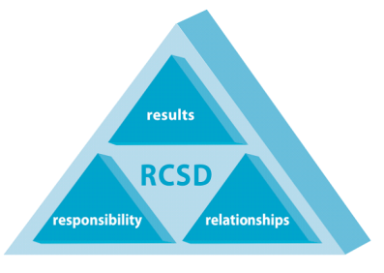
Gina Sudaria
Superintendent
Board Members:
Mele K. Latu, President
Tamara Sobomehin, Vice President
Bronwyn Alexander, Clerk
Ana Maria Pulido, Member
Jenny Varghese Bloom, Member
Ravenswood City School District
ADMINISTRATIVE OFFICE
2120 Euclid Avenue, East Palo Alto, California 94303
(650) 329-2800 Fax (650) 323-1072

“OUR CHILDREN – OUR FUTURE”

RESOLUTION NO. 2021/2022 – 9 -1

RESOLUTION FOR ADOPTING THE “GANN” LIMIT

Ravenswood City School District

WHEREAS, in November of 1979, the California electorate did adopt Proposition 4, commonly called the Gann Amendment, which added Article XIII-B to the California Constitution; and,

WHEREAS, the provisions of that Article establish maximum appropriation limitations, commonly called “Gann Limits,” for public agencies, including school districts; and,

WHEREAS, the District must establish a revised Gann limit for the 2020-21 fiscal year and a projected Gann Limit for the 2021-22 fiscal year in accordance with the provisions of Article XIII-B and applicable statutory law; and,

WHEREAS, Government Code Section 7902.1 provides that school districts may increase their Gann Limits under specified circumstances;

NOW, THEREFORE, BE IT RESOLVED that this Board does provide public notice that the attached calculations and documentation of the Gann limits for the 2020-21 and 2021-22 fiscal years are made in accord with applicable constitutional and statutory law;

AND BE IT FURTHER RESOLVED that this board does provide public notice that the attached calculations and documentation of the Gann Limits for the 2020-21 and 2021-22 fiscal years include an increase of $6,974,320.55 to the 2020-21 Gann Limit pursuant to the provisions of Government Code Section 7902.1;

AND BE IT FURTHER RESOLVED that the Superintendent notifies the Director of the State Department of Finance of the increase to the 2020-21 Gann Limit;

AND BE IT FURTHER RESOLVED that this Board does hereby declare that the appropriations in the Budget for the 2020-21 and 2021-22 fiscal years do not exceed the limitations imposed by Proposition 4;

AND BE IT FURTHER RESOLVED that the Superintendent provides copies of this resolution along with the appropriate attachments to interested citizens of this district.

REGULARLY passed and adopted this 9th day of September, 2021.

AYES ________ NOES________ ABSENT________ ABSTAINED________

_________________________________ ____________________________
Secretary President

_____________________________
Date Approved/Filed

