BERKELEY UNIFIED SCHOOL DISTRICT

TO: Brent Stephens, Ed. D., Superintendent
FROM: Rubén Aurelio, Associate Supt. of Educational Services
DATE: October 20, 2021
SUBJECT: 2021-22 Student Admissions Update

BACKGROUND INFORMATION
On June of 2015, the Berkeley Board of Education approved a new Admissions and Enrollment Policy (BP5111). The policy directs staff to provide an annual enrollment update to the Board. Presently, Berkeley Unified School District (BUSD) has 9208 students enrolled in district schools. The projected student enrollment for the 2021-22 school year was 9432. The present student population of 9208 students enrolled in BUSD schools represent 97.62% of the student projection. Due to the ongoing Covid-19 pandemic, some families have not enrolled their children in school. Some families have moved out of Berkeley, the state and out of the country. And other families have decided to send their children to private schools.

The Admissions and Enrollment Policy requires students transitioning from 5th grade to 6th grade and from 8th grade to the 9th grade to certify that they continue to be Berkeley residents. Of approximately 678 fifth graders, 638 (94.1%) registered to continue onto BUSD middle schools. There were about 709 eighth graders in BUSD’s middle schools during the 2020-21school year and 694 (97.9%) complied with the enrollment policy requirements in order to continue onto Berkeley High School.

There was extensive outreach on the part of the Admission Office to assist new families and families transitioning to middle school and high school. Families whose children were transitioning to middle and high school were informed in writing, emails, via individual phone calls and communications from the elementary and middle schools about the rematriculating process. In addition, since the summer, the Admissions Office has been open in order to assist families who can not submit documents electronically.

In order to ascertain the compliance of the Berkeley residency requirements, at times it has been necessary to conduct address verifications. District staff has visited 165 residences of students enrolling for the 2021-22 school year. Of the address verifications, 28 (17%) students were not enrolled in Berkeley Unified Schools because families were not truthful about their Berkeley residency. The address verifications have been conducted throughout Berkeley, Oakland and West Contra Costa. The accompanying map indicates where the bulk of the address verifications have taken place.

Berkeley Unified School District has also accepted students on inter-district permits. There are 957 students attending BUSD on inter-district permits. The 957 inter-district students represent 10.4% of the BUSD student population. For the 2021-22 school year, 146 new students were admitted into BUSD schools. Of the 146 granted inter-district permits, 46 were for children of BUSD employees who do not live in Berkeley. Additionally, 19 students were admitted because they had siblings attending BUSD schools and 82 were accepted under administrative discretion. An accompanying table details the numbers of permits granted and denied by grade.

BUSD also denied 65 inter-district permit requests for the 2021-22 school year. The denied permits were for new students requesting admission into BUSD. The students were not accepted because they did not meet the requirements of grades attendance and behavior as established by Board policy or because they did not submit all the necessary documents for consideration. Other families were accepted but, in the end, did not enroll in BUSD schools.

Berkeley residents also requested inter-district permits to attend public schools outside of Berkeley. 72 students requested inter-district permits for the 2021-22 school-year to attend non BUSD schools. The breakdown for the students opting not to attend BUSD is as follows: 32 for elementary school, 18 for middle school and 22 for high school.

POLICY/CODE
Board Policy 5111, Student Admissions and Enrollment

FISCAL IMPACT
None

STAFF RECOMMENDATION
Receive 2021-22 student admissions update report for information.

Address Verification Map

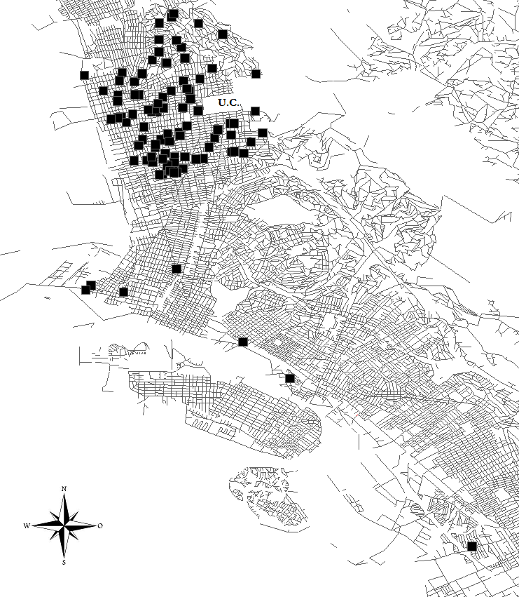

2021 -2022 Inter-district Permits
 | Approved |  |  | Denied
Grade | Continuing | New | Total | Continuing | New | Total
TK | 0 | 11 | 11 | 0 | 3 | 3
K | 0 | 48 | 48 | 0 | 4 | 4
1 | 44 | 6 | 50 | 0 | 3 | 3
2 | 44 | 12 | 56 | 0 | 5 | 5
3 | 54 | 2 | 56 | 0 | 5 | 5
4 | 42 | 4 | 46 | 0 | 5 | 5
5 | 64 | 2 | 66 | 0 | 5 | 5
Elem Total | 248 | 85 | 333 | 0 | 30 | 30
 |  |  |  |  | 6
6 | 50 | 8 | 58 | 0 | 11 | 11
7 | 66 | 4 | 70 | 0 | 2 | 2
8 | 76 | 2 | 78 | 0 | 0 | 0
Mid Total | 192 | 14 | 206 | 0 | 13 | 13
9 | 72 | 33 | 105 | 0 | 10 | 10
10 | 89 | 8 | 97 | 0 | 8 | 8
11 | 107 | 3 | 110 | 0 | 3 | 3
12 | 103 | 3 | 106 | 0 | 1 | 1
High Total | 371 | 47 | 418 | 0 | 22 | 22
Grand Total | 811 | 146 | 957 | 0 | 65 | 65
Reason for Accepting New Students
Grade | BUSD Employee | County Appeal | Sibling | Ext. Circumst. | Admin. Discretion | Total
TK | 6 |  | 3 |  | 2 | 11
K | 22 |  | 6 |  | 20 | 48
1 | 2 |  | 3 |  | 1 | 6
2 |  |  |  |  | 12 | 12
3 |  |  |  |  | 2 | 2
4 | 2 |  |  |  | 2 | 4
5 | 1 |  |  |  | 1 | 2
6 | 2 |  | 1 |  | 5 | 8
7 | 2 |  |  |  | 2 | 4
8 | 1 |  |  |  | 1 | 2
9 | 4 |  | 6 |  | 23 | 33
10 | 2 |  |  |  | 6 | 8
11 | 2 |  |  |  | 1 | 3
12 |  |  |  |  | 3 | 3
Total | 46 | 0 | 19 | 0 | 81 | 146

